Dalton Murray

Systems Analysis and Design

INT 6123 – Systems Analysis and Design

Dr. Andrew Makar

November 5, 2023

**IA #9 Spring Breaks R Us**

I will be using my previously created domain model class diagram to create the relational database schema, as the solution which has been posted into Canvas, Chapter 04, I believe to be less detailed than the one which I have created for the solution. I will, however, create modifications to my existing domain model class diagram in order to ensure that it will properly work when translating into database form. I have also voluntarily taken to using phpMyAdmin rather than Excel as I already have years of experience using it and prefer it as it will allow me to create an actual database for this which will aid me in ensuring that it is properly made, is actually usable, and is in third normal form, 3NF. It also does not list Excel to be the required program to use to create the tables and database.

Considerable amounts of time have been used for careful consideration of the database, its tables, and the relationships to ensure that everything is in third normal form and works perfectly. When doing this, I have also used the built-in phpMyAdmin designer to show off the tables and their relationship. This image which I have created is attached below (also attached):

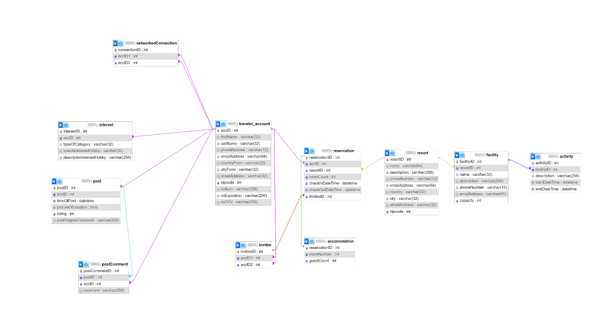

Unfortunately, I concluded that this built-in designer for the diagram is rather low-quality, primarily because of how the lines are drawn otherwise it would be great, however, it does the job in showing off the tables and connection in diagram form. I have, also, recreated my existing diagram with the new data and relationships I have made, which is attached below (also attached):

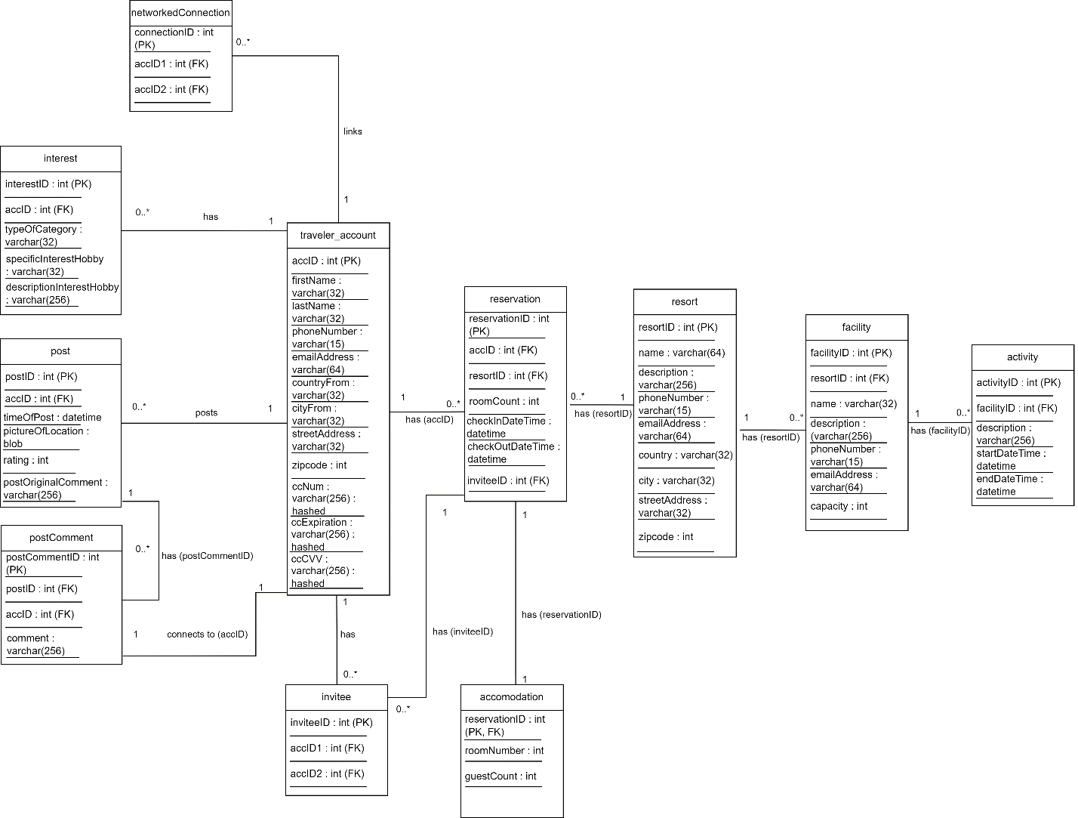

With this new diagram I drew, it shows the specific details of the databases, primary keys, foreign keys, and relationships between connections.

The following are now pictures of each of the structures in the database (also attached):

Traveler/Individual account:

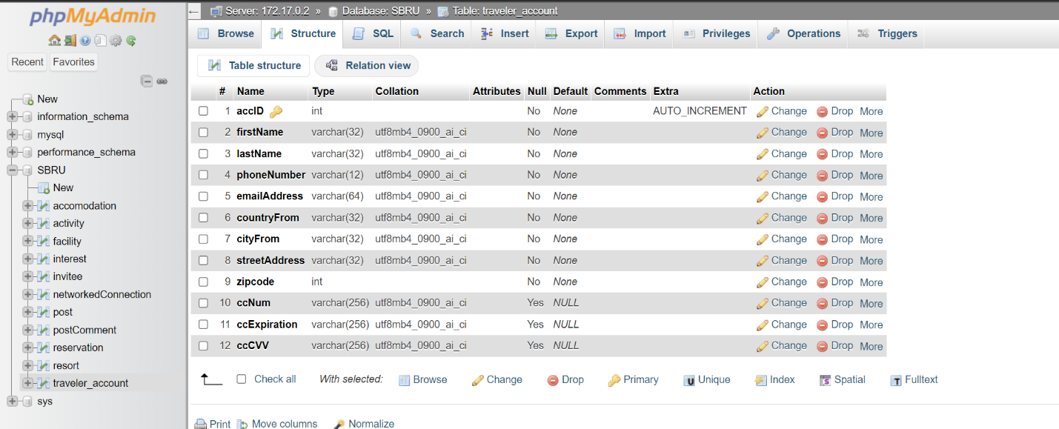

Invitee:

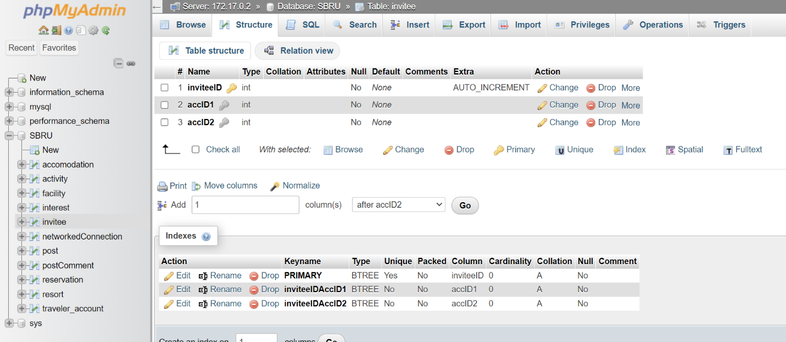

Accommodation:

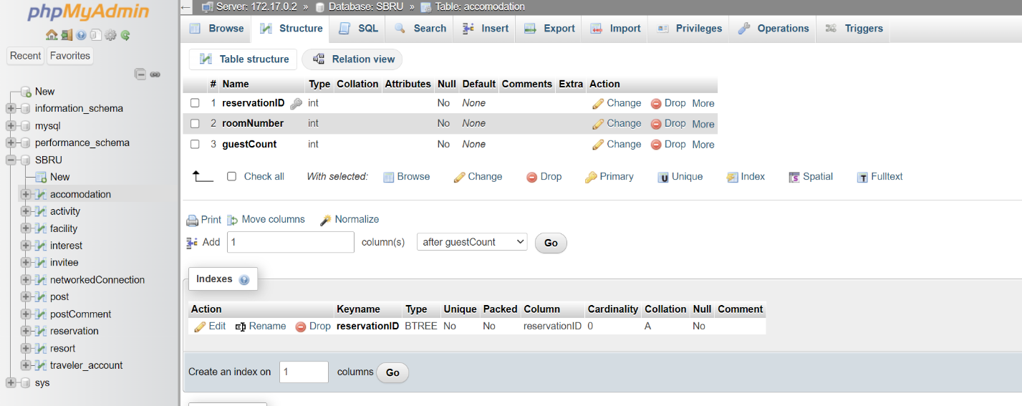

Reservation:

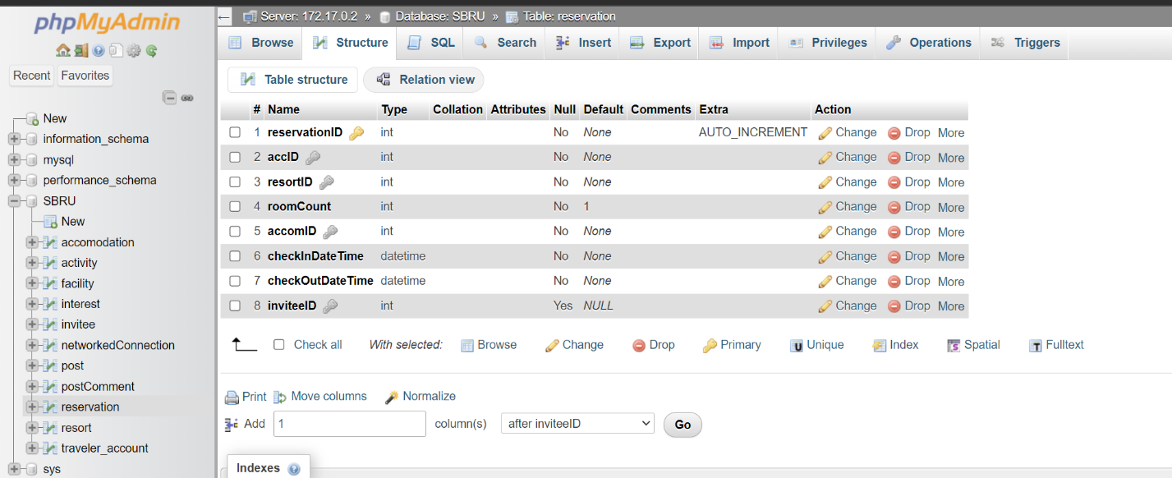

Resort:

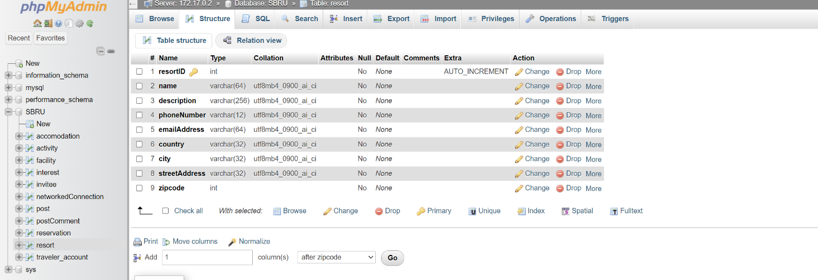

Facility:

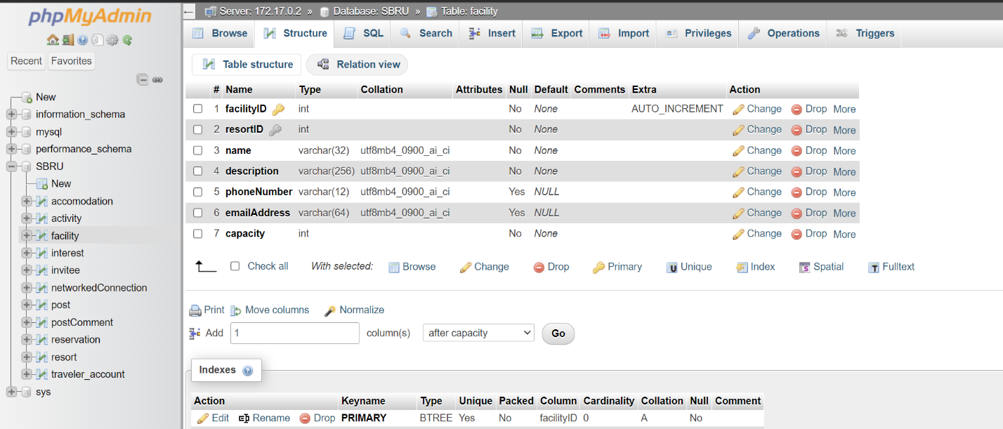

Activity:

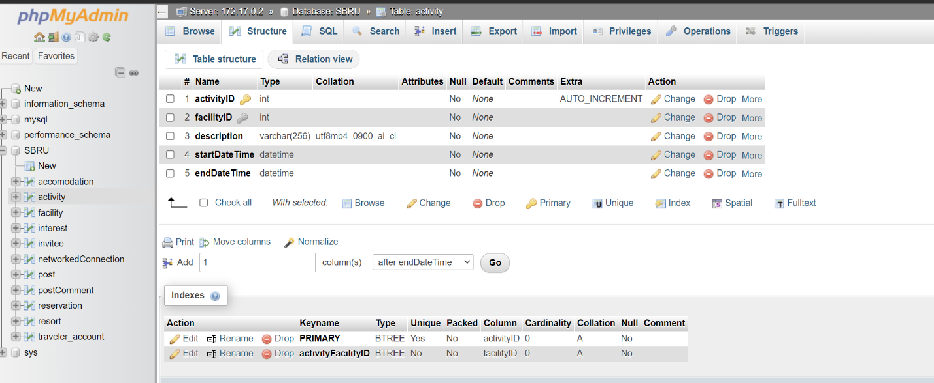

Networked connection:

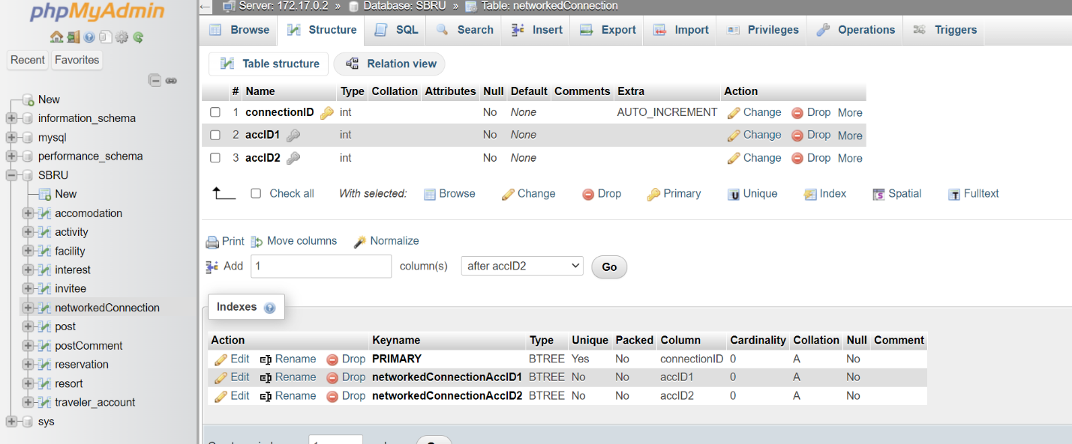

Interest:

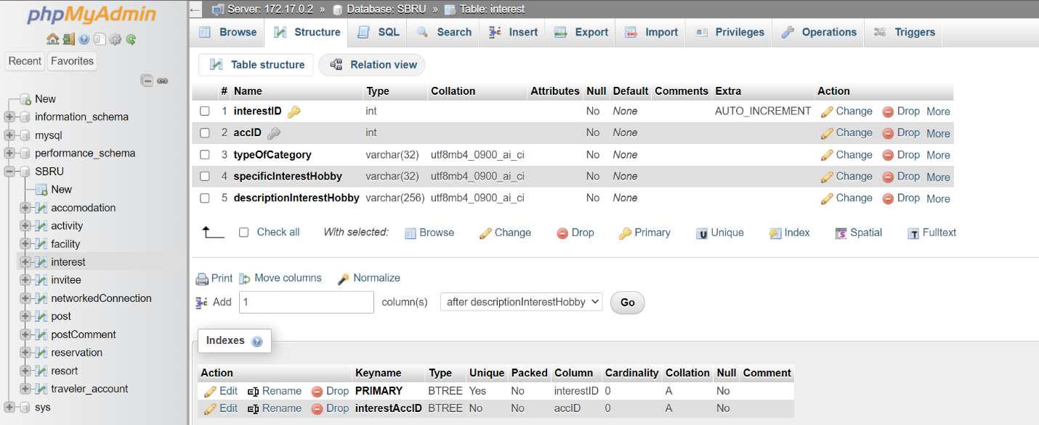

Post:

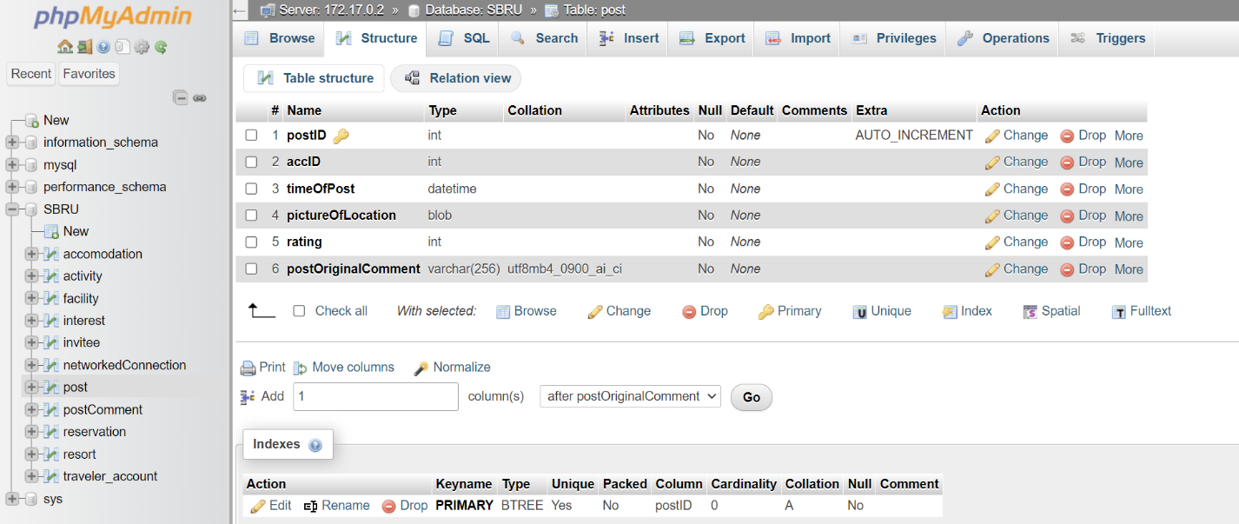

Post comment:

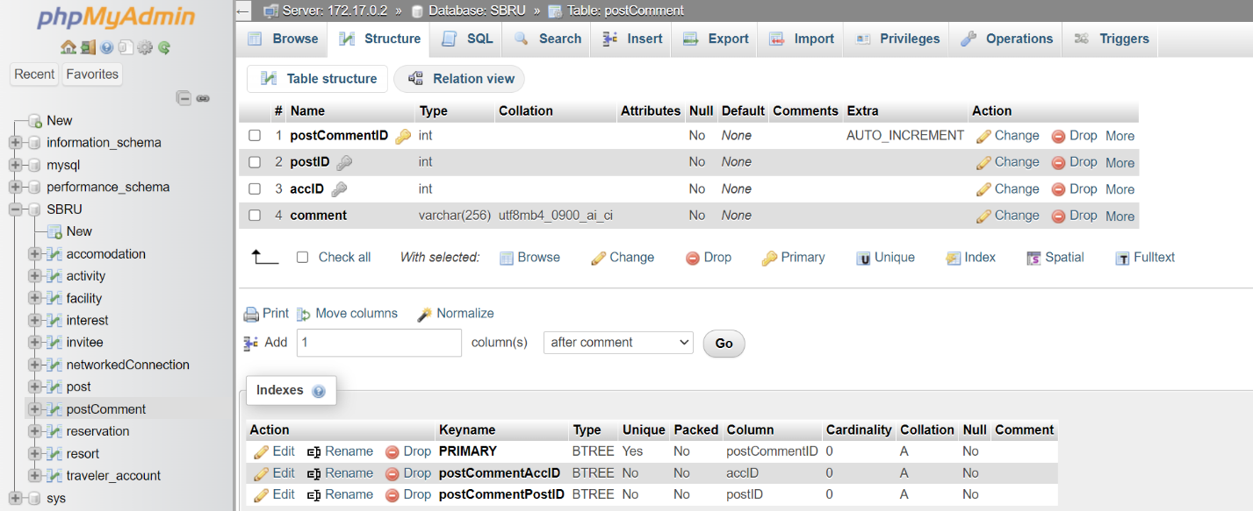

Now, here are the tables with an example line of data:

Traveler/Individual account:

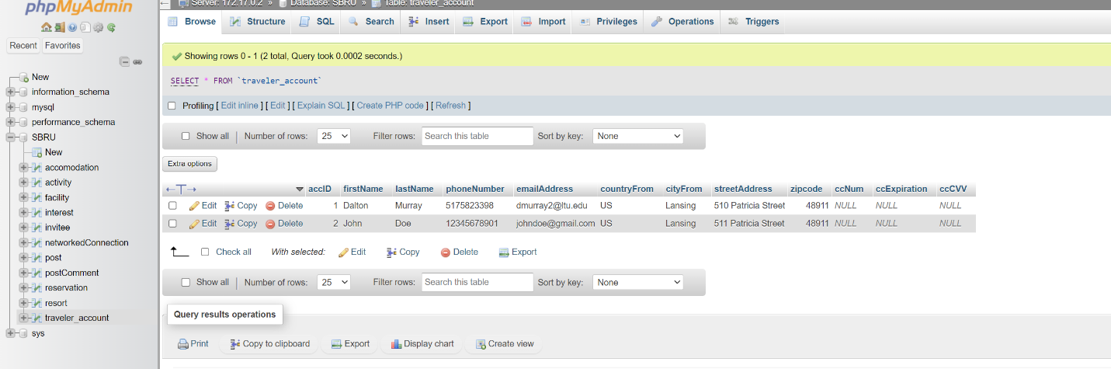

Invitee:

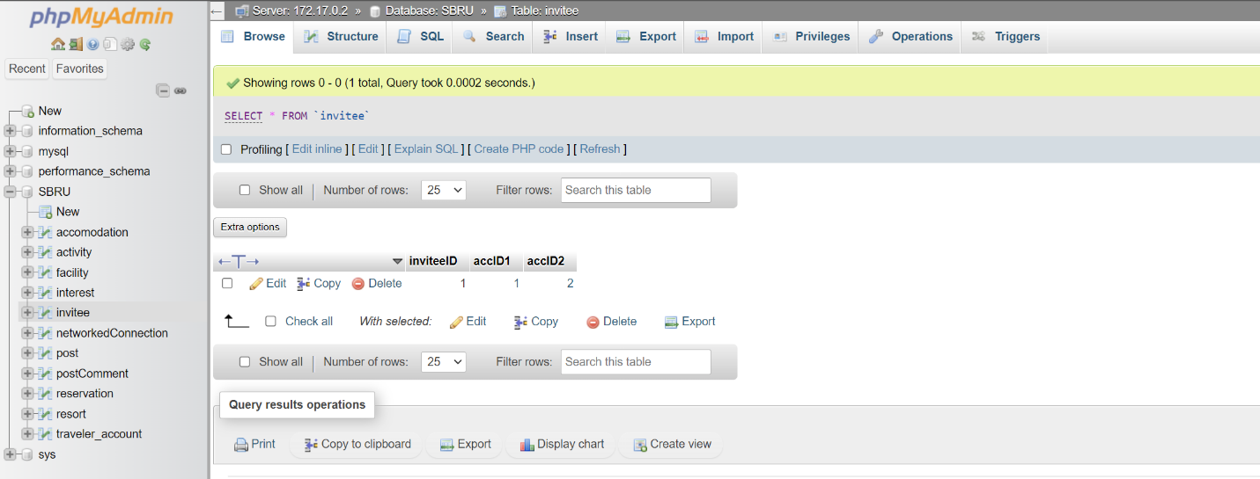

Accommodation:

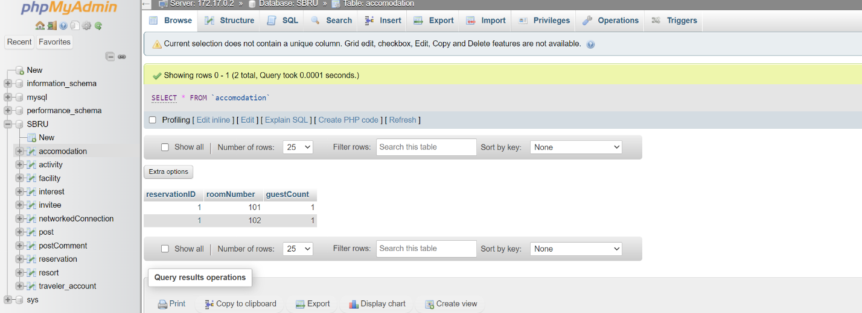

Reservation:

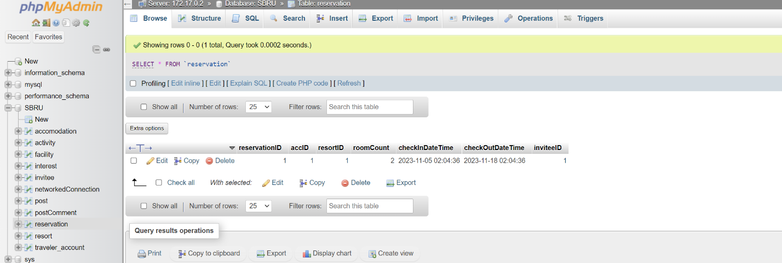

Resort:

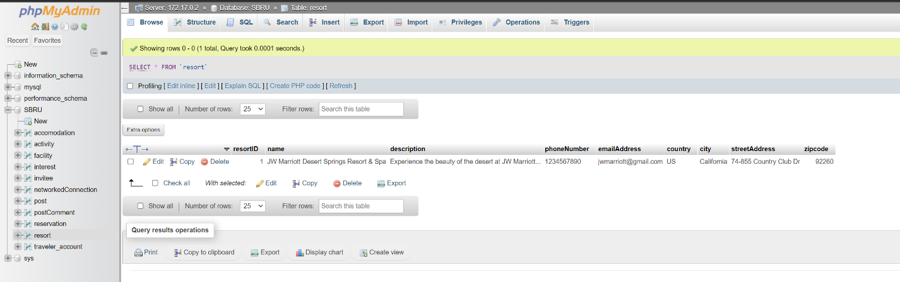

Facility:

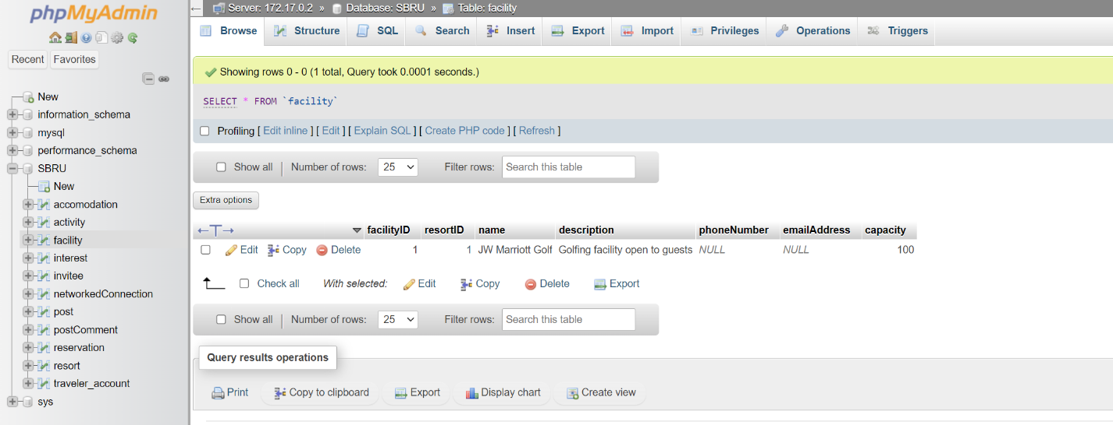

Activity:

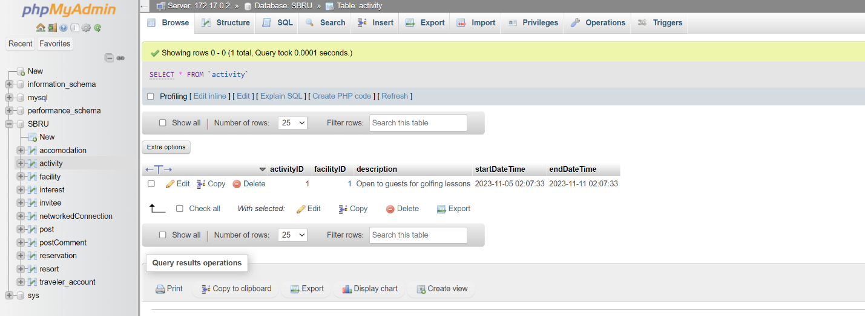

Networked connection:

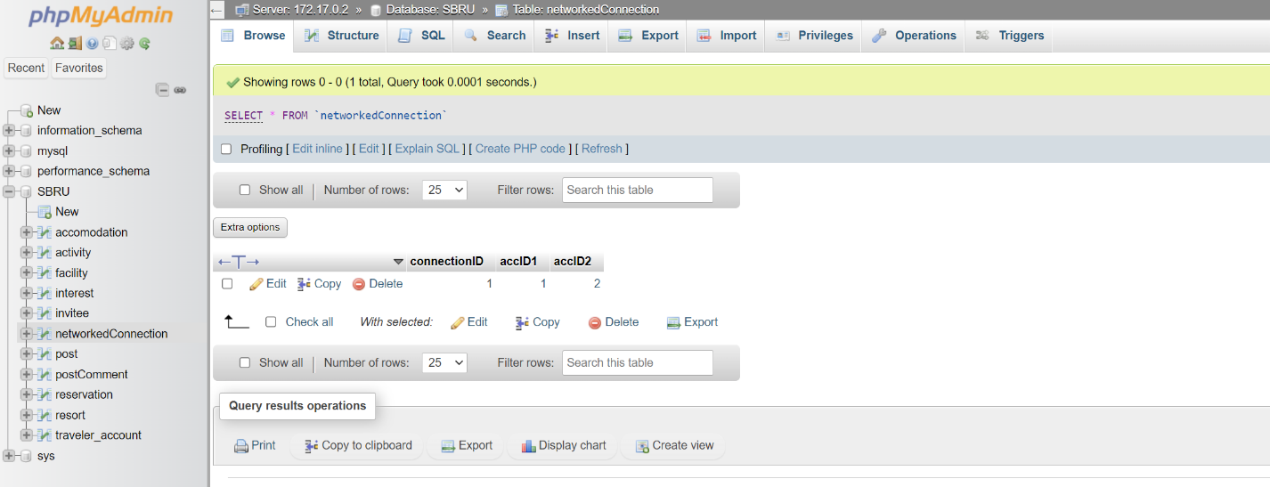

Interest:

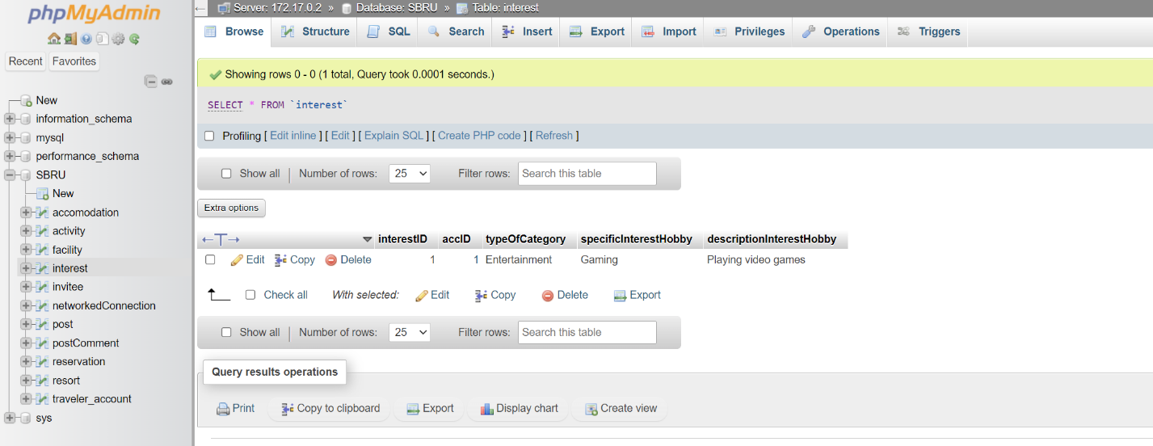

Post:

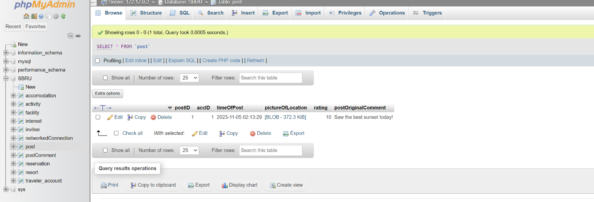

Post comment:

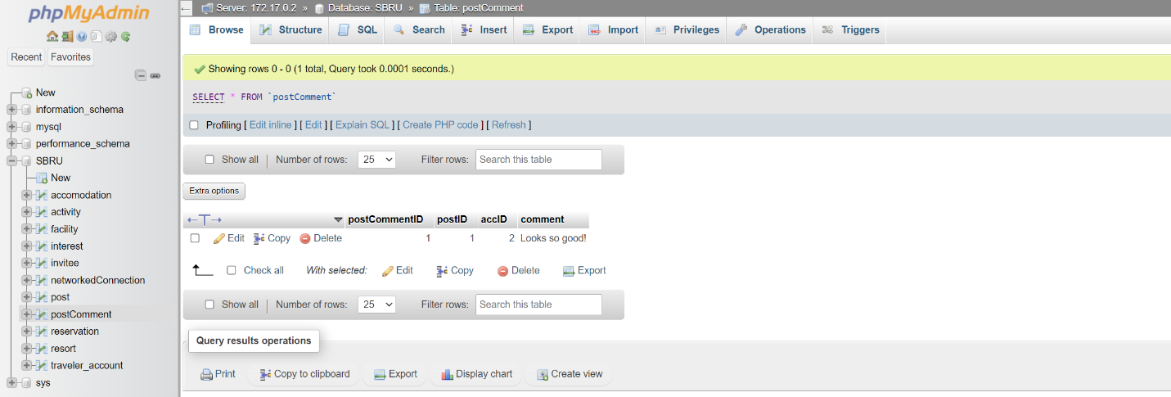

All tables are in 3NF.

1NF – Each cell only contains a single value, each column has a unique name (Satzinger et al., 2016. p. 273 – 275).

2NF – Functional dependency – No non-key attribute depends on anything other than the primary key (Satzinger et al., 2016. p. 275 - 276).

3NF – Functional dependency – All non-key attributes are functionally independent of each other non-transitively other than the primary/candidate keys. Although the book argues about the country, state, and city are dependent on the zipcode, it is functionally not in this database. All data inputted would be directly taken from the form online for reservations, account creation, etc. and are not based off of each other in the database (whereas if it were the zipcode would be getting calculated based off of the country, state, city or the other way around where they are determined based off of the zipcode).

There were quite a few discrepancies between my database design and the domain class model diagram. These are primarily because the database is much more complex and designed to actually work versus the domain class model diagram being designed to be a general overview of everything that is needed. I also included new columns/data in the actual database design compared to the domain class model diagram. An example of a discrepancy is the need of breaking down the resort into reservation, accommodation, resort, facility and activity rather than having them all together.

I have also attached a .sql export of the database created.

**References**

Satzinger, J. W., Jackson, R. B., & Burd, S. D. (2016). Systems analysis and design in a Changing World (7e ed.). Cengage Learning.

I have neither given nor received unauthorized aid in completing this work, nor have I presented someone else's work as my own.

*Dalton Murray*